PRAGAN TUITIONS

What is VSEPR Theory?
VSEPR theory explains the shape of molecules and bond angles in molecules where atoms are connected by covalent bonds.
The basic idea:
Electron pairs in the valence shell of the central atom repel each other and arrange themselves as far apart as possible to minimize repulsion.
Because of this repulsion, molecules get specific shapes.

Important Points of VSEPR (Write These in Exams)

1.Electron pairs repel each other
- Both bond pairs (shared electrons) and lone pairs (unshared electrons) repel.
- They are called charge clouds.

2. Shape depends on number of electron pairs
If we know:
- Total bond pairs
- Total lone pairs
We can predict:
- Arrangement of electron pairs
- Shape of the molecule
- Bond angle

3.Lone pairs occupy more space
Repulsion order:
Lone pair – Lone pair > Lone pair – Bond pair > Bond pair – Bond pair
Because lone pairs are attached to only one nucleus and spread out more.

Valence Shell Electron Pair Repulsion (VSEPR) theory was proposed by Sidgwick and Powell and later improved by Gillespie and Nyholm. According to this theory, the electron pairs present in the valence shell of the central atom repel each other and arrange themselves as far apart as possible to minimize repulsion. This determines the shape of the molecule.

Both bond pairs and lone pairs repel each other. Lone pairs occupy more space than bond pairs. The order of repulsion is:

Lone pair–Lone pair > Lone pair–Bond pair > Bond pair–Bond pair.

If there are two bond pairs and no lone pairs, the molecule is linear with bond angle 180°.
If three bond pairs and no lone pairs, the molecule is trigonal planar with bond angle 120°.
If four bond pairs and no lone pairs, the molecule is tetrahedral with bond angle 109°28′.
If lone pairs are present, bond angles decrease due to greater repulsion.

Thus, VSEPR theory helps in predicting the shape and bond angle of molecules.

Limitations of VSEPR Theory
- Cannot explain bond strength.
- Based on Lewis structure only.
- Does not explain electronic nature of covalent bonds.
To explain bonding better, Valence Bond Theory was proposed by Linus Pauling.

Shapes of Molecules

Linear Shape
If central atom has:
- 2 bond pairs
- 0 lone pairs
They arrange opposite to each other.
Bond angle = 180°
Example: BeCl₂
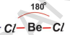

Trigonal Planar
If central atom has:
- 3 bond pairs
- 0 lone pairs
They form a triangle in one plane.
Bond angle = 120°
Example: BF₃
Note: BF₃ is an electron deficient molecule (only 6 electrons around B).
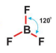

Tetrahedral
If central atom has:
- 4 bond pairs
- 0 lone pairs
They arrange in 3D at corners of tetrahedron.
Bond angle = 109° 28′
Example: CH₄ (Methane)

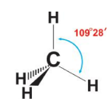

Trigonal Pyramidal
If central atom has:
- 3 bond pairs
- 1 lone pair
Lone pair pushes bond pairs closer.
📐 Bond angle = 107° 48′ (less than 109°28′)
Example: NH₃ (Ammonia)
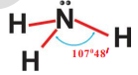

Bent / V-Shape
If central atom has:
- 2 bond pairs
- 2 lone pairs
More repulsion → bond angle decreases further.
Bond angle = 104° 31′
Example: H₂O (Water)

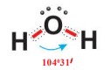

Why Bond Angle Decreases?
From CH₄ → NH₃ → H₂O:
109°28′ → 107°48′ → 104°31′
Because number of lone pairs increases, and lone pairs repel more strongly.

Valence Bond Theory (VBT)

Proposed by: Linus Pauling (1954)

What is Valence Bond Theory?

Valence Bond Theory explains how a covalent bond is formed using the concept of orbital overlap.

Main idea:

A covalent bond is formed when two atoms come close and their half-filled atomic orbitals overlap. The overlapping orbitals contain electrons of opposite spins, which pair up and form a bond.

Important Points of Valence Bond Theory

Bond formation by overlap
- Each atom must have at least one half-filled orbital.
- When two half-filled orbitals overlap, electrons with opposite spins pair up.
- The shared electron pair is attracted by both nuclei.
- This holds the atoms together → covalent bond is formed.

Greater overlap = Stronger bond
- More overlapping of orbitals → stronger bond.
- Less overlapping → weaker bond.

Atoms keep their orbitals
- Even after bond formation, each atom keeps its own atomic orbitals.
- The electron pair is shared in the overlapping region.

Sigma (σ) and Pi (π) Bonds

When two atoms form bonds:

Sigma (σ) Bond
- Formed by head-on (end-to-end) overlap
- Overlap occurs along inter-nuclear axis
- Stronger bond
- First bond formed between two atoms is always σ bond

Pi (π) Bond
- Formed by sidewise (lateral) overlap
- Weaker than sigma bond
- Formed after sigma bond in multiple bonds

Example 1: Formation of Cl₂ Molecule

Electronic configuration of Cl:

1s² 2s² 2p⁶ 3s² 3p⁵

In 3p orbitals:
- One electron is unpaired (in 3p orbital)

When two Cl atoms come close:
- 3p orbital of one Cl overlaps with 3p orbital of other Cl
- Opposite spin electrons pair
- Cl–Cl bond is formed (σ bond)

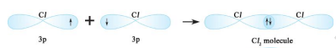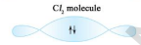

Formation of N₂ Molecule (Valence Bond Theory)
- Nitrogen has atomic number 7 and its electronic configuration is 1s² 2s² 2p³. Thus, it has three unpaired electrons in the 2px, 2py and 2pz orbitals.
- Each nitrogen atom requires three more electrons to complete its octet. When two nitrogen atoms approach each other, they share three pairs of electrons.
- The 2px orbital of one nitrogen atom overlaps head-on with the 2px orbital of the other nitrogen atom along the inter-nuclear axis forming a sigma (σ) bond. The 2py orbital of one nitrogen atom overlaps laterally with the 2py orbital of the other nitrogen atom forming one pi (π) bond.
- Similarly, the 2pz orbitals overlap laterally forming another pi (π) bond.
- Thus, one sigma bond and two pi bonds are formed between the two nitrogen atoms. Therefore, the N₂ molecule contains a triple bond (N≡N). The presence of one σ bond and two π bonds makes the nitrogen molecule very stable and strong.

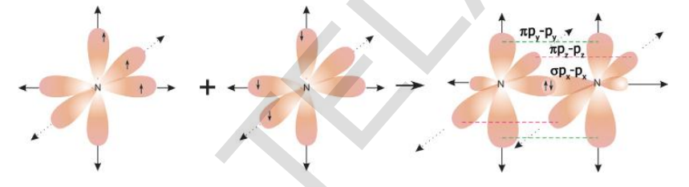

Formation of O₂ Molecule (Valence Bond Theory)

Oxygen has atomic number 8 and its electronic configuration is 1s² 2s² 2p⁴. In the 2p orbitals, two electrons are paired in one orbital and one unpaired electron is present in each of the other two orbitals. Thus, each oxygen atom has two unpaired electrons and requires two more electrons to complete its octet.

When two oxygen atoms approach each other, they share two pairs of electrons. The 2py orbital of one oxygen atom overlaps head-on with the 2py orbital of the other oxygen atom along the inter-nuclear axis forming a sigma (σ) bond. The 2pz orbital of one oxygen atom overlaps laterally with the 2pz orbital of the other oxygen atom forming a pi (π) bond.

Thus, one sigma bond and one pi bond are formed between the two oxygen atoms. Therefore, the O₂ molecule contains a double bond (O=O). The presence of one σ bond and one π bond makes the oxygen molecule stable.

Formation of BeCl₂ Molecule

Electronic configuration of Be (ground state):
Be (Z = 4) → 1s² 2s²
It has no unpaired electrons, so it should not form covalent bonds.
- Excited state of Be:
One electron from 2s orbital is promoted to 2p orbital.
New configuration: 1s² 2s¹ 2p¹
Now Be has two unpaired electrons.
- Problem without hybridisation:One bond would form by overlap of 2s (Be) with 3p (Cl).
  - Other bond would form by overlap of 2p (Be) with 3p (Cl).
  - Since orbitals are different, bond strengths should be different.
  - But experimentally, both Be–Cl bonds are equal and bond angle is 180°.
- Concept of Hybridisation (Proposed by Linus Pauling):
“Hybridisation is the intermixing of atomic orbitals of nearly equal energy to form the same number of new identical orbitals.”
- Hybridisation in BeCl₂:
  - 2s and one 2p orbital of Be intermix.
  - Two identical sp hybrid orbitals are formed.
  - Each sp orbital contains one unpaired electron.
- Shape and Bond Formation:
  - The two sp orbitals arrange in opposite directions (180° apart).
  - Each sp orbital overlaps with a 3p orbital of chlorine.
  - Two identical σ (sp–p) bonds are formed.
- Conclusion:
  - BeCl₂ has two identical Be–Cl bonds.
  - The molecule is linear.
  - Bond angle Cl–Be–Cl = 180°.

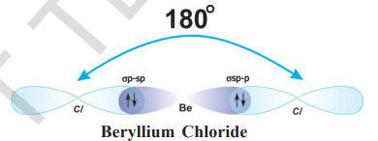

Formation of BF₃ Molecule
- Electronic configuration of Boron (ground state):
B → 1s² 2s² 2p¹
It has only one unpaired electron, so it should form only one bond. But actually it forms three bonds in BF₃.
- Excited state of Boron:
One electron from 2s is promoted to 2p.
New configuration: 1s² 2s¹ 2p²
Now boron has three unpaired electrons.
- Hybridisation:
One 2s and two 2p orbitals intermix to form three identical sp² hybrid orbitals.
Each sp² orbital has one unpaired electron.
- Bond formation:
Each sp² orbital overlaps with one 2p orbital of fluorine forming three identical σ (sp²–p) bonds.
- Shape:
The three sp² orbitals arrange at 120° to each other.
Therefore, BF₃ is trigonal planar with bond angle 120°.

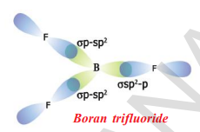

Formation of NH₃ Molecule
- Electronic configuration of Nitrogen:
N (Z = 7) → 1s² 2s² 2p³
It has three unpaired electrons in 2px, 2py and 2pz orbitals.
- Problem without hybridisation:
If three hydrogen atoms overlap their 1s orbitals with three p orbitals of nitrogen, three σ (p–s) bonds would form.
The bond angle should be 90°, but experimentally H–N–H angle is 107°48′.
- Hybridisation:
To explain this, nitrogen undergoes sp³ hybridisation.
One 2s and three 2p orbitals intermix to form four identical sp³ hybrid orbitals.
- Electron distribution:
  - One sp³ orbital contains a lone pair.
  - The other three sp³ orbitals contain one unpaired electron each.
- Bond formation:
Three hydrogen atoms overlap their 1s orbitals with three sp³ orbitals of nitrogen forming three identical σ (s–sp³) bonds.
- Bond angle and shape:
The expected bond angle for sp³ hybridisation is 109°28′.
Due to lone pair–bond pair repulsion, the bond angle decreases to 107°48′.
Hence, NH₃ has a trigonal pyramidal shape.

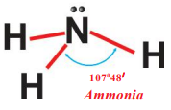

Shape of Water (H₂O) Molecule
- Electronic configuration:
Oxygen (Z = 8) → 1s² 2s² 2p⁴
Hydrogen (Z = 1) → 1s¹
Oxygen has two unpaired electrons.
- Problem without hybridisation:
If two hydrogen atoms overlap their 1s orbitals with two p orbitals of oxygen, two σ (s–p) bonds would form.
The bond angle should be 90°, but experimentally HOH angle is 104°31′.
- Hybridisation:
Oxygen undergoes sp³ hybridisation.
One 2s and three 2p orbitals intermix to form four identical sp³ hybrid orbitals.
- Electron distribution:
  - Two sp³ orbitals contain lone pairs.
  - Two sp³ orbitals contain one unpaired electron each.
- Bond formation:
Two hydrogen atoms overlap their 1s orbitals with two sp³ orbitals of oxygen forming two σ (sp³–s) bonds.
- Bond angle and shape:
Expected angle for sp³ hybridisation = 109°28′.
Due to lone pair–lone pair and lone pair–bond pair repulsions, the bond angle decreases to 104°31′.
Therefore, H₂O has a bent (V-shaped) structure.
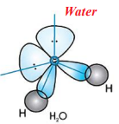

Polar and Non-Polar Compounds

Polar Covalent Bond
- When two different atoms form a covalent bond, the shared electrons shift towards the more electronegative atom.
- The more electronegative atom gets partial negative charge (δ–).
- The other atom gets partial positive charge (δ+).
- Such molecules are called polar molecules.
Example: HCl
Hδ+ — Clδ–

Ionic Compounds
- Oppositely charged ions are held by strong electrostatic forces.
- They are solids at room temperature.
- They have high melting and boiling points.
- They are soluble in polar solvents like water.
- Reactions in solution are fast due to rearrangement of ions.
Example: NaCl

Covalent Compounds
- Molecules are held by weak intermolecular forces.
- Usually gases or liquids at room temperature.
- They have low melting and boiling points.
- Soluble in non-polar solvents.
- Reactions are slow because bonds must break and reform.

Meaning of “Like Dissolves in Like”
“Like dissolves in like” means:
A solute dissolves in a solvent that has similar type of bonding and polarity.
- Polar or ionic substances dissolve in polar solvents (like water).
- Non-polar covalent substances dissolve in non-polar solvents.

